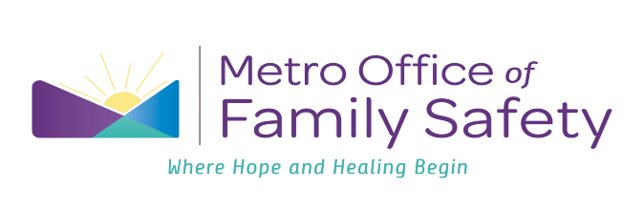
Job Title: Programmatic Macro Intern
Department: Office of Family Safety
Reports to: Intern, Volunteer & Outreach Coordinator
Full/Part Time: Full Time
Location: Family Safety Center/Community
Summary:
The Programmatic Macro Intern is responsible for assisting the Community Outreach Advocate and Assistant Director of Community Engagement with the daily roles/tasks of the Nashville Family Safety Center and community needs. The Programmatic Macro intern plays a key role in supporting victims through community outreach and programmatic initiatives including social media, website management, fundraising and grants as well as direct client services.

Essential Duties and Responsibilities:
Community Relationships
- Help build and maintain community partnerships with local organizations/agencies by providing direct client services as needed.
- Attend community outreach
- Help coordinate donation and fundraising drives for the Family Safety Center and Jean Crowe Advocacy Center
Administrative
- Write, edit, and distribute monthly department newsletter
- Create an inventory system for donations
- Track and record donation/donor information
- Support Special Projects Manager with tracking court data
- Assist Grant Manager with grant initiatives
Social Media/Technology
- Collaborate with Office Manager on maintenance of OFS’ social media pages
- Create new materials for social media pages
- Assist with website maintenance and updates
- Stock supply closet and take inventory of donations
Miscellaneous
- Support children’s services program by assisting Child Trauma Specialist in Play Pyramid as needed
- All other duties as assigned
Qualifications:
- Must be at least 18 years old
- Must pass a background check
- Must be currently enrolled in an undergraduate or post graduate program
- Bilingual/Multilingual applicants are especially encouraged to apply

To Apply:
Please send a completed application, cover letter, and resume to Josie Carter at JosieECarter@jisnashville.gov

